**Theory**

**Java** has Graphical User Interface (GUI) feature by which many types of graphical expression can be printed on the screen by importing some packages. This packages contains many classes that help to make the GUI with Java. These classes are such as **JFrame**, **JPanel** and **JApplet**. The GUI component classes , such as **JButton**, **JTextField**, **JTextArea**, **JCombobox**, **JList**, **JRadioButton** and **JMenu** are subclasses of **JMenu**. The Helper Classes, such as **Graphics**, **Color**, **Font**, **FontMetrics** and **Dimension**.

**Printing “This is my Dialog Box” in a Dialog Box.**

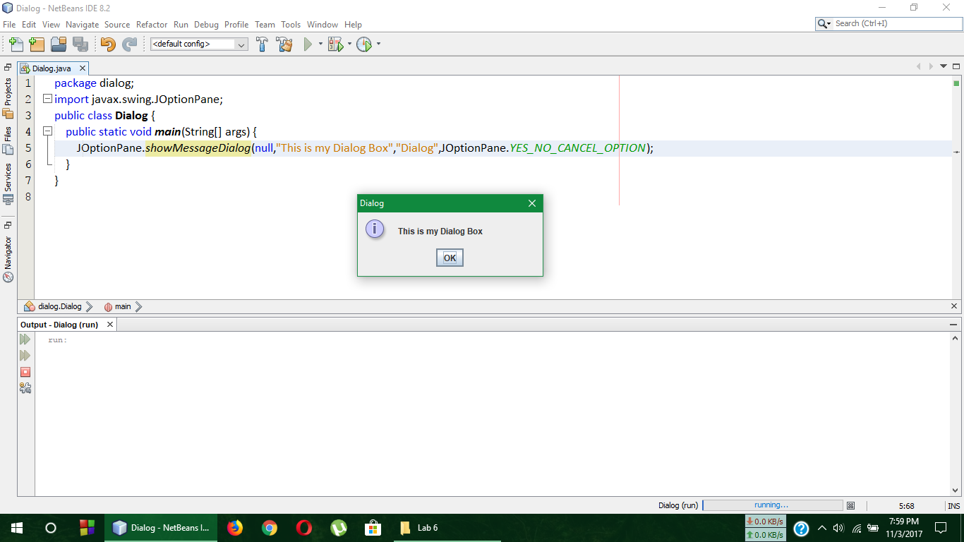**Code**

**Output**



**Comment**

In the above code, **javax.swing.JOptionPane** was imported to print the message in a dialog box.

And **showMessageDialog()** was a function of **JOptionPane** object.

**Adding two numbers in dialog box**

**Code**

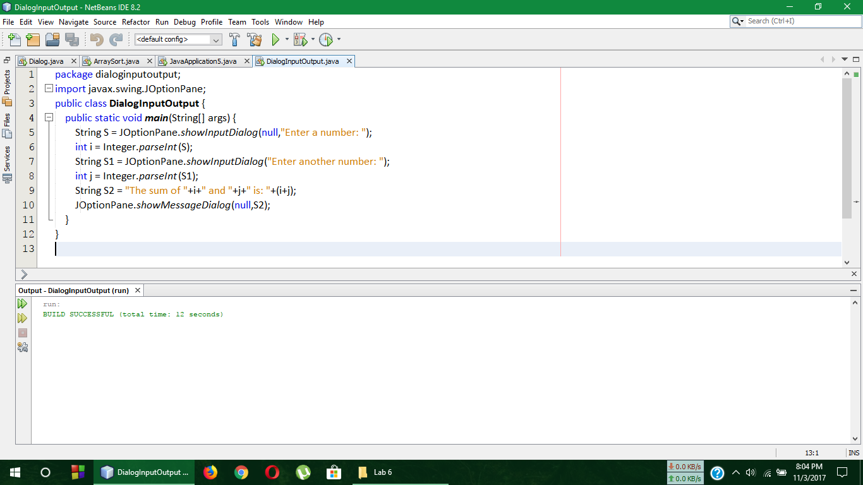

**Output**

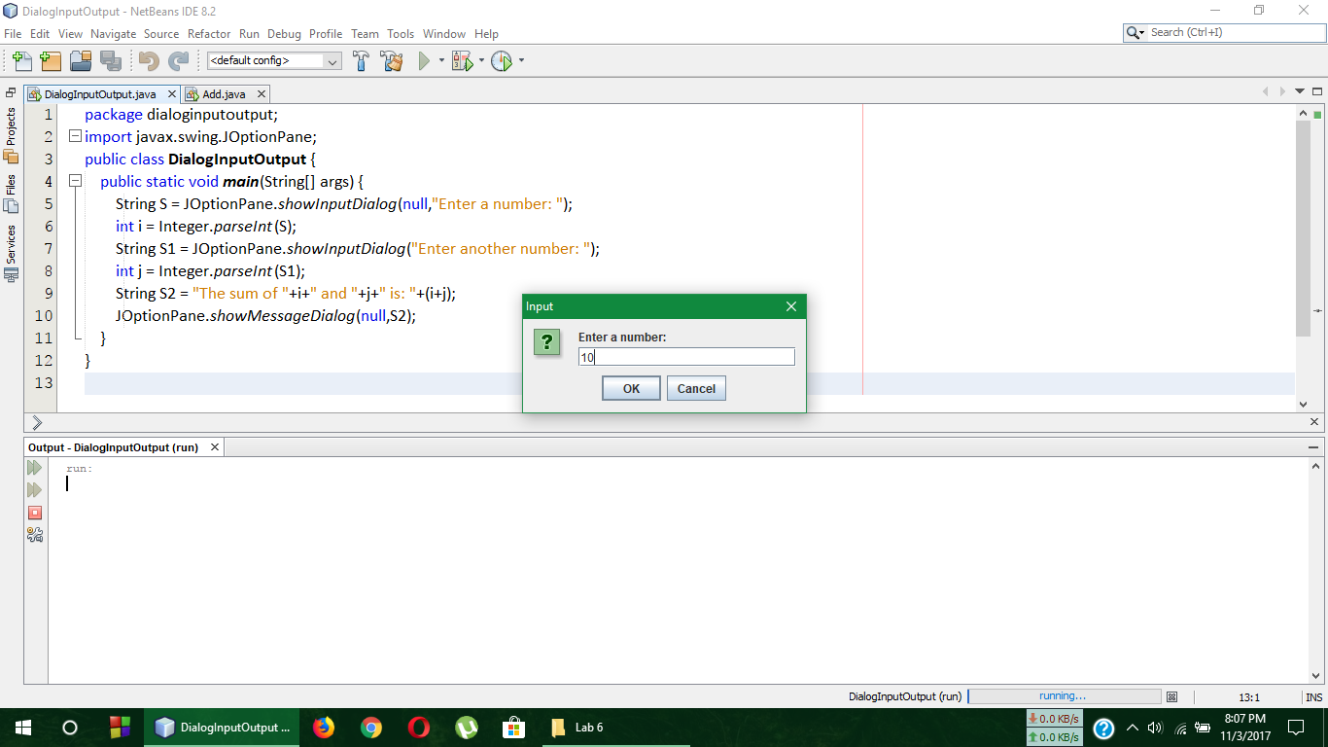

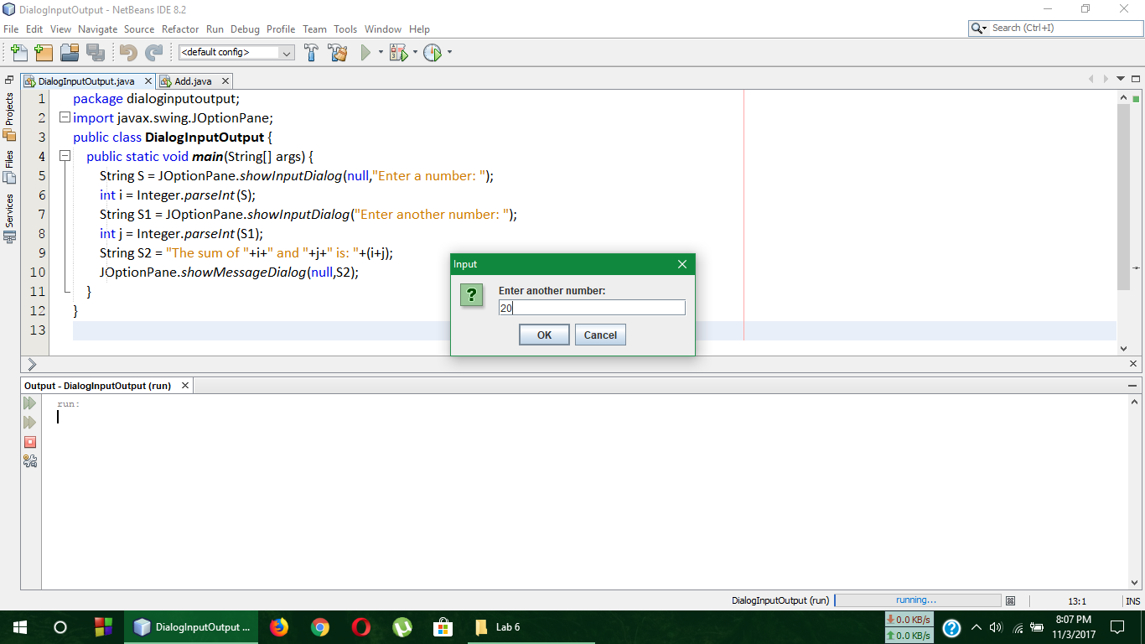

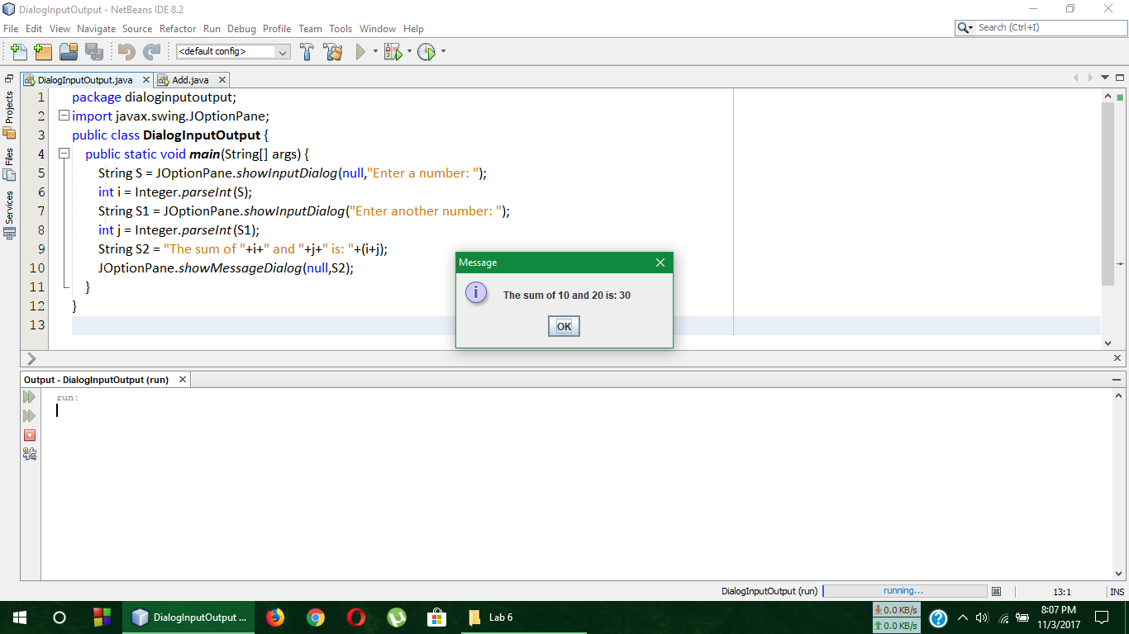

**Comment**

In the above code, using JOptionPane two numbers were taken from the user in dialog box and was printed their sum in another dialog box.

**Sorting 100 random numbers in a Dialog Box**

**Code**

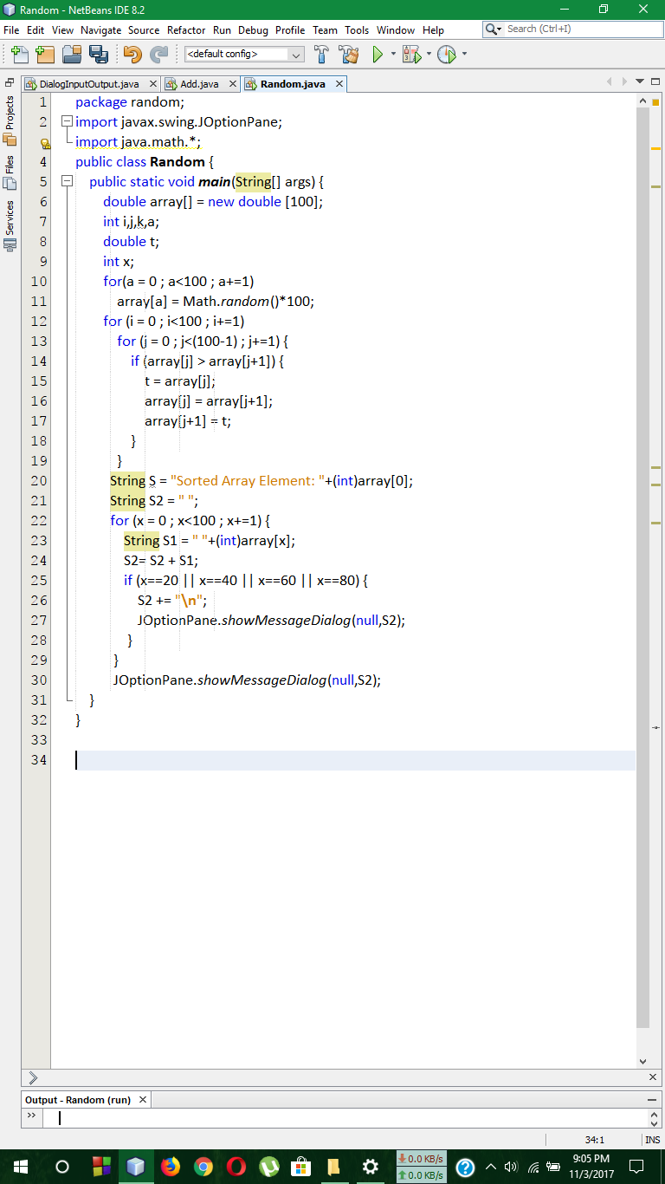

**Output**

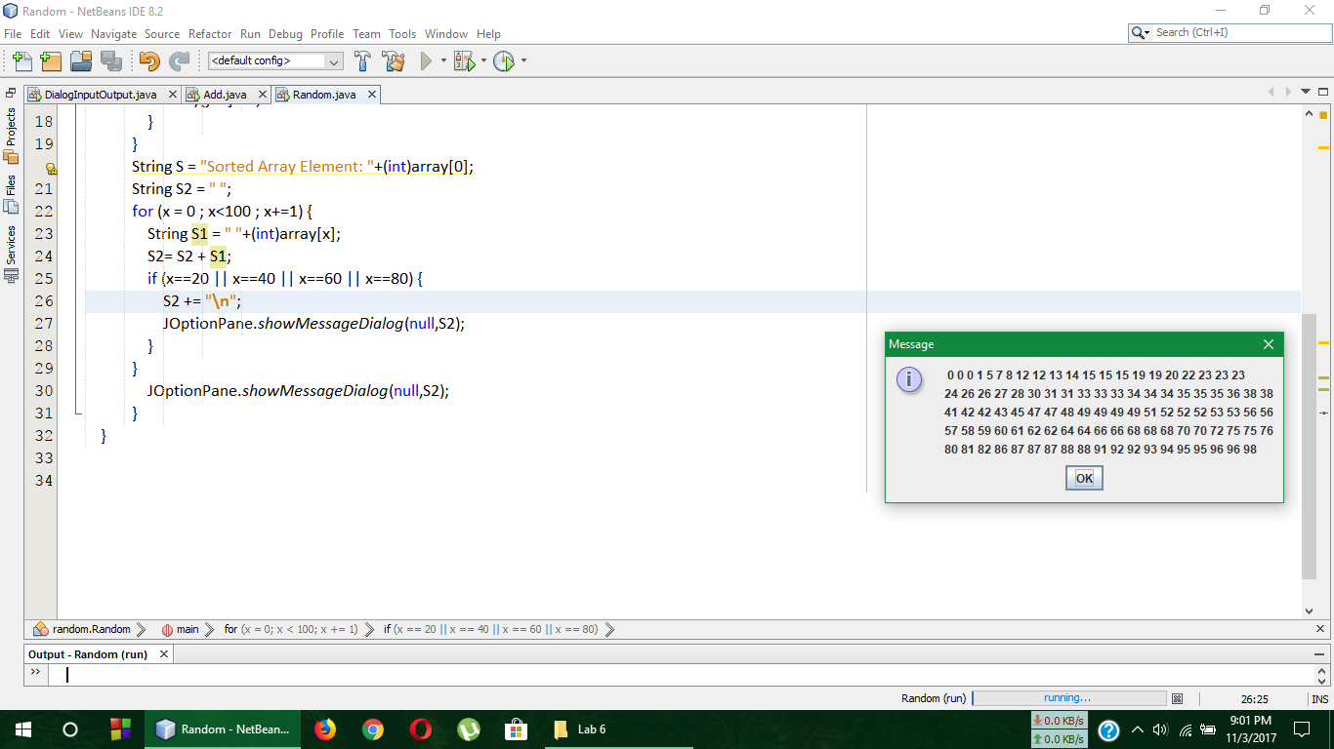

**Comment**

In the above code, a function named **random()** under **math** object was used for random inputs of number and then using **JOptionPane** the sorted array was printed on the dialog box.